Chapter 6
A Review of predictive maintenance of bearing Failures in rotary machines by predictive analytics using machine-learning techniques

Yasser N. Aldeoes¹, Dr. Prasad Ghockle², Dr. Shilpa Y. Sondkar³
Department of Computer Engg, Vishwakarma University, Pune, India^{1,2}
Department of Instrumentation Engg, Vishwakarma Institute of Technology, Pune, India³
yasser.aldeoes-043@vupune.ac.in, prasad.gokhale@vupune.ac.in, shilpa.sondkar@vit.edu
Abstract. Maintaining product and machine safety while lowering maintenance costs has recently become a serious concern. Predictive maintenance is one important strategy for achieving this (PdM). ML is a good candidate for PdM since current machines come with a large quantity of operational data. PdM and ML for rotary systems (Bearing failures) have both been discussed extensively in review publications. The number of articles in this sector is growing, emphasizing the necessity for a study like this. in this paper, we conduct analyze modern academic articles that were published database of ScienceDirect, Scopus, Institute of Electronics and Electrical Engineers (IEEE), and Google Scholar from 2017 until the beginning of June 2021. To sum up, predictive maintenance is a popular issue in the context of Industry 4.0, but it comes with a number of problems that need to be properly researched in the fields of machine learning and application thinking. This study presents a detailed overview of machine learning algorithms for bearing failure prediction, including the most often used ML techniques.
.
Keywords: Predictive Maintenance, Bearings, Machine learning, Classification, Rotating machinery.
- Introduction
Recently, investments in manufacturing machines today have become widespread in various vital fields, especially in production lines, despite being expensive, complex, and very specialized, which means that maintaining the safety of every part of the machine, directly controlling and treating it is to maintain the production chain as a whole and it is good Preserving time caused by machine downtime due to maintenance periods and unsuited failures, which in turn lead to idleness and stoppage of the entire production line due to the failure of one of the machine components. To reduce these costs, it is necessary to identify these errors in advance.
Undoubtedly, Industrial 4.0 or “Industrial Internet of Things” (IIoT) introduced a rampage and fundamental changes in industrial automation, decision-making, and data analysis in a significant and remarkable way, as the “Internet of Things” technology played a pivotal turn in the implementation and creation of smart products in various fields.[1] This leads to a smart reality with smart specifications, services, and proper planning for these environments from data collected by several devices located in various areas of industries. In addition, Industrial systems capture a huge amount of data that comprises data about events, processes, and alarms that happen along a production line[2]. Furthermore, when these data are processed and evaluated, they can yield useful knowledge and information about industrial processes and system dynamics. Interpretive outcomes for strategic decision-making are feasible by using analytic approaches based on data, which provide benefits such as lesser maintenance rates, fewer contrivance faults, fewer repair stops, lower extra parts stock, lengthy spare parts life, upgraded production, improved repair confirmation, operator safety, and overall profit[3]. With the significant in-crease of many industries in using IoT-supported designs and investigating through how IoT keys can provide novel advantage, IoT has proven to be changing the performance rules for many businesses. The origination of IoT conectivity never ceases to amaze, from self-driving cars to smart homes loaded with voice-activated pieces of equipment [4]. Predictive analytics are used in a variety of ways by companies depending on their needs, ranging from predictive marketing and data mining to the use of machine learning (ML) algorithms and artificial intelligence (AI) to improve the behavior of business processes and identify trends and new statistical forecasts[5]. The goal of this research is to look at the challenges of using machine learning techniques in predictive maintenance and to look at current trends in how failures are forecast. The most essential factors in designing concepts like a predictive maintenance decision support system were failure prediction. It also looked at all frameworks in Industry 4.0 that apply machine learning for predictive maintenance. This post has notably contributed to raising awareness of the difficulties in establishing and applying predictive maintenance[6]. The development and implementation of an online mistake diagnosis system based on ML methods is described and addressed in this paper. An in-house test setup is used to implement a built fault detection system based on the provided approach, and the consistently discovered results imply that such a system might be commonly used to expect various problems in power drivetrains[7]. Generally, maintenance is divided into three types: Run-to-Failure (R2F) or reactive maintenance, Predictive Maintenance (PdM) and Preventive Maintenance (PvM). The following main classifications can be used to categorize techniques for maintenance policies.
- Reactive maintenance or Run-to-Failure (R2F): Maintenance just in the event of a failure, also known as reactive maintenance, is conducted only when something breaks or fails. but this type of maintenance leads to big financial loss-es due to both equipment repairs to be replaced and downtime of plants that adding a cost[8].
- Preventive maintenance (PvM): This type of maintenance is popular as it is based on pre-planned scheduled times (weekly, monthly, or yearly) and is performed on a time period to anticipate process/equipment failure. This approach is effective in avoiding failure. However, through it, unnecessary corrective actions are taken that lead to increased operating costs.
- Condition-based-Maintenance (CBM): This maintenance technique is dependent on continuous equipment or machine checking, as well as their process health, which can be performed just when necessary. Only when activities on the progression are taken following one or other conditions of process degeneration can maintenance actions be carried out. CBM cannot typically be planned ahead of time.
- Predictive maintenance (PdM): It is a strategy that has intelligent predictive tools that include all technologies that rely on continuous machine monitoring and early detection and prevention of potential failures. Includes operational procedures based on historical data (such as ML techniques) and (artificial intelligence)[9].
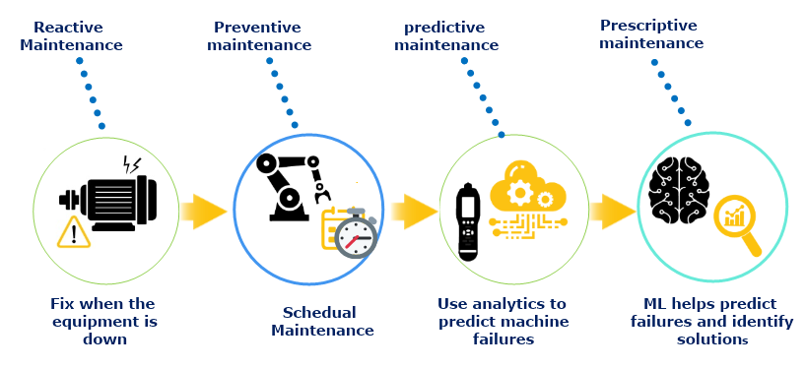

Fig 1. Maintenance types (Past and future).
Improving the dependability, availability, and safety of modern industrial systems and applications is critical for lowering maintenance costs. As a result, monitoring the health of machinery like induction motors is critical. In rotary machines, the bearing is a crucial component[10]. To improve detection, diagnosis, monitoring, and prognosis capabilities, Intelligent condition monitoring and defect detection and diagnostic technologies are crucial for improving detection, diagnosis, monitoring, and prognosis capabilities. Stress, aging, vibration, and lengthy working times impact all parts of general rotary machines (stator, bearing, bar, and rotor). As a result, any failure of any part might result in a major breakdown of the machine, increasing maintenance costs and causing significant losses[11].

Fig.2 Describes the percentage of rotary machine faults.
As a result, machine learning (ML) offers powerful prediction methodologies for PdM applications. So, the success of these applications is contingent on the correct deployment of machine learning techniques. As a result, the purpose of this study is to give a review that covers the most widely published PdM methodologies based on ML methods that collected from Scopus and IEEE databases, ScienceDirect. The remnant of this paper will be planned as follows: Section 2 defines the Survey and Analysis for related work. Section 3 presents Related work Technical background. Section 4 Predictive Maintenance and Machine learning Techniques. Section 5 Applications of Machine learning Algorithms in PdM. Section 6 Discussion and Conclusions.
- Survey and Analysis for related work
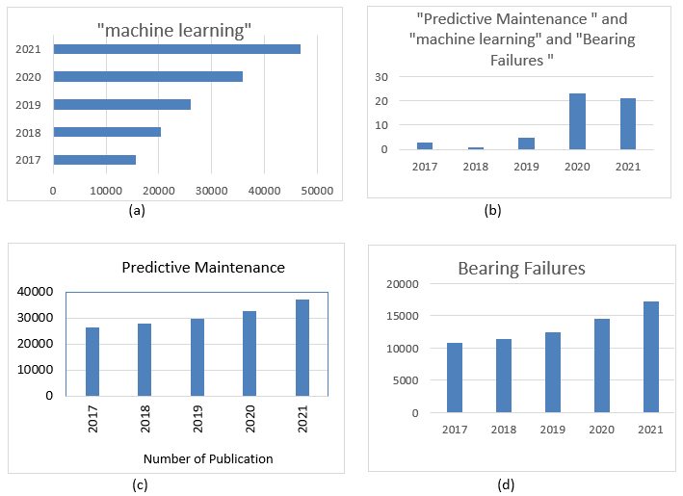
In this review, includes articles from the database of Scopus, IEEE, ScienceDirect, and Google Scholar. The four databases mentioned above aided in the development of the PdM's theoretical foundations, ML approaches, bearing failures, and ML algorithms. The articles in this review were gathered from ScienceDirect and IEEE and divided into four areas. The publications in the first set were gathered from ScienceDirect and IEEE, and the search was based on "machine learning."
Fig 3. Statistics from ScienceDirect and IEEE and Scopus database (Date: 2017 to 2021), Documents are published with the keywords: (a) "Machine Learning". (b) "Machine Learning",” Predictive Maintenance”, ”Bearing failures ”. (c) "Predictive Maintenance ". (d) "Bearing failures ".

The articles in the second set were found using the search term "Predictive Maintenance". The items in the third group were found by a search based on " Bearings failure". This group is utilized as supporting work in the contexts of the introduction and the common of research, with data acquired from the databases mentioned above assisting in the development of theoretical foundations for PdM, bearing failure and ML methods,. Figure.3 depicts the number of documents published annually in the last five years between 2017 and 2021. As can be observed in Figure 4, The PdM based of ML techniques in have captivated the interest of researchers recently ( last five years). Because there were so few papers published before 2017, The focus has been on the number of published articles between 2017 to 2021. As a result, It may be concluded that applying machine learning techniques to the subject of PdM is a novel strategy that is gaining popularity in the scientific community. This could be owing to a rise in the amount of data [12]. (PdM) Predictive Maintenance is a expression that refers to a group of techniques that are applied to monitor and measure the condition of equipment that is in use (e.g., a engine, automobile, etc.). So long as analyses is perfect with adequate frequency, PdM technologies permit the user to discover most potential failures well in advance. PdM is a good case of the type of industrial sensor networking applications that have a demonstrable impact in real-world deployments..
- Technical background
All In the wide preponderance of machines, bearings are among the greatest critical components. A new strategy is introduced, atrous convolution (ACDIN) to aimed for cope among the problem and improves the accuracy from 75% to 96% on detecting the present bearing errors once skilled with only the data created from false bearing scratches then ACDIN takes signals as new inputs to analyze the mechanism performance among artificial broken bearings and normal spoiled bearings [13]. It is necessary and important to know the technical background to classify the behavior and approaches of machine learning and the processes themselves, for example, the technical background for fault bearings. Therefore, it is necessary to clarify in this portion the dissimilar and common types of defects that is possible look in bearings[13]. Bearings, generally consists of outer and inner ring, cage, and rollers[14].
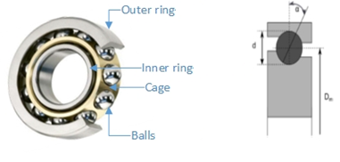
As indicated in Fig. 4, the balls are positioned between the outer and inner rings. The cage is where the balls are kept in their respective locations with relation to one another. A bearing defect can be caused by a fault in any of the four bearing elementals, however the inner, outer rings are estimated that 90% of all faults[15]. For different bearing components rotating inner ring and outer ring and ball (Fig.5)
Fig 5. Bearing in side and front view

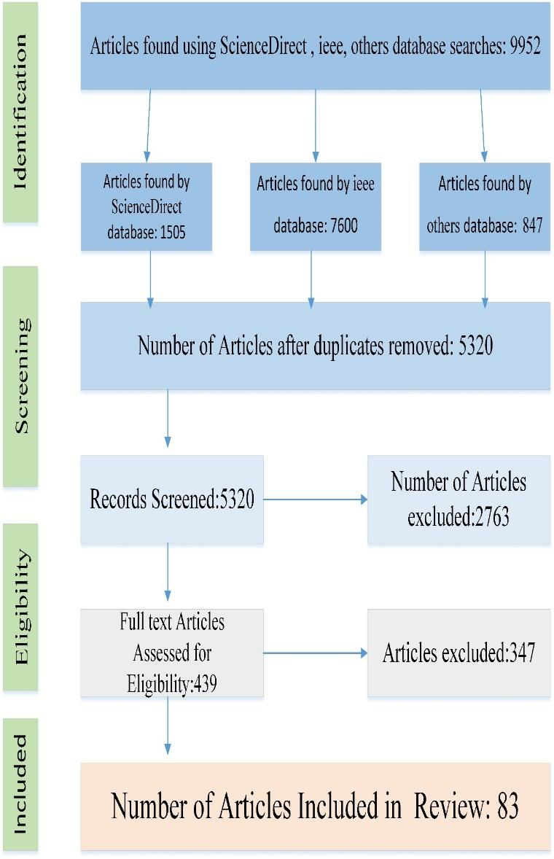
Fig 4. Survey flowchart.

The following is how the fundamental frequencies are determined from the bearing geometry:

$$f_{c/o} = f_{r}/2 [1 –\frac{d}{D_{m}} Cos α ] (1)$$
$$f_{c/i} = f_{r}/2 [1 +\frac{d}{D_{m}} Cos α ] (2)$$
$$f_{b/o} = Z f_{c/o} (3)$$
$$f_{b/i}= Z f_{c/i} (4)$$
$$f_{b} = 〖f_{r} D_{m}〗/2d [1 – (\frac{d}{D_{m}} Cos α)^{2}] (5)$$

$f_{c/o}$ = frequency of fundamental train (cage) relative to outer ring, $f_{r}$ = Inner ring rotational frequency, $d$ = Diameter of roller elements, $D_{m}$ = Pitch circle diameter, $α$= Contact angle, $f_{c/i}$ = frequency of fundamental train relative to inner ring,${ f}_{b/i}$= Ball pass frequency of inner raceway (BPFI), $f_{b/o}$ = Ball pass frequency of outer raceway (BPFO)$f_{b}$ = frequency of rolling element rotational, $Z$ = Number of rolling elements. from Eqs (1) – (5) The bearing fault may be calculated whereas the frequency created by the balls rolling across the surface of the rings is caused by reiterated impacts every time the rolling parts contacts a flaw.
Whenever there is abnormality on a component, where a frequency component at , $f_{c/i}$ , ${ f}_{b/o}$, $f_{b/i}$ or , $f_{r}$ appear incase the similar fault happens. Nonetheless, once the errors are in the soon stages, the frequency parts are very tiny which causes complexities for a discovery of the trouble frequencies between a large number of frequencies current and, The actual fault frequencies may differ from those computed. This is because those frequencies are calculated depending on the hypothesis of no-skid, which is incorrect [16][17]. Even so, the most important defy in the implementation of the analyses of these frequencies and how to select them to obtain real results. Nevertheless, the analyses of the historic records to well bearing for contrast purposes can provide suitable outcomes[18]. Detecting bearing problems has been the focus of many articles[19][20]. There are causes of bearing failure types that can occur in many different forms: The excessive load usually causes premature spalled area in the ball path. also Overheating causes discoloration of rings, balls, and cages, the temperature rise can also destroy lubricant decreases or degrade the bearing capacity causing early failure. Overwork failure usually pointed to as spalling is the split of the running surfaces and following removal of small discrete particles of body. Pollution is one of the primary reasons of bearing failure, with denting of the bearing raceways and balls resulting in huge vibration and token of damage and clear. Overheating, Excessive wear, and consequent bearing failure will occur if the lubricant fails. [21][22][23]. bearing failure is generally caused by a lack of maintenance and overloading . however, many other things can cause premature bearing failure as well. Some are rising temperatures, wetness, pollution, improper misalignment, lubrication, electric current flow through the bearing, and excessive thrust or overloading [24]. (SHI et al.2021) introduced a unique bearings safe operating technique based on (VMD) variational mode decomposition methods and AlexNet neural network for diagnostic and fault detection in a complicated and high noise environment[25]. When using a low-cost MEMS accelerometer to diagnose bearing faults on complicated rotating equipment, high frequency noise might be a concern. (Ompusunggu et al., 2019) suggested an unique automated diagnostics approach for high-end accelerometer performance that is similar to low-cost accelerometer performance[26]. The interplay in the vibration signals has an impact on the bearing failure characteristics. When a rolling portion passes ended a damaged surface, an unwary force is produced, which causes resonances in the bearing and machine[27]. The location of faults, rotation velocity, and bearing dimensions may all be used to compute the duration of the impulses, or characteristic frequency.
- Predictive Maintenance and Machine learning Techniques
Over time, many machine learning-based predictive maintenance strategies have proven to be the most successful. To do predictive maintenance, the sensors must be connected to the system, and the sensor will track and collect data about the activities of the system. Sensor data for predictive maintenance helps an ML-based application accurately predict failures with real-time and accurate. However, the ML algorithms are categorized into three different classes in figure.6 as follows: (1) Supervised[28], (2) Unsupervised[29], (3) Reinforcement learning[30].
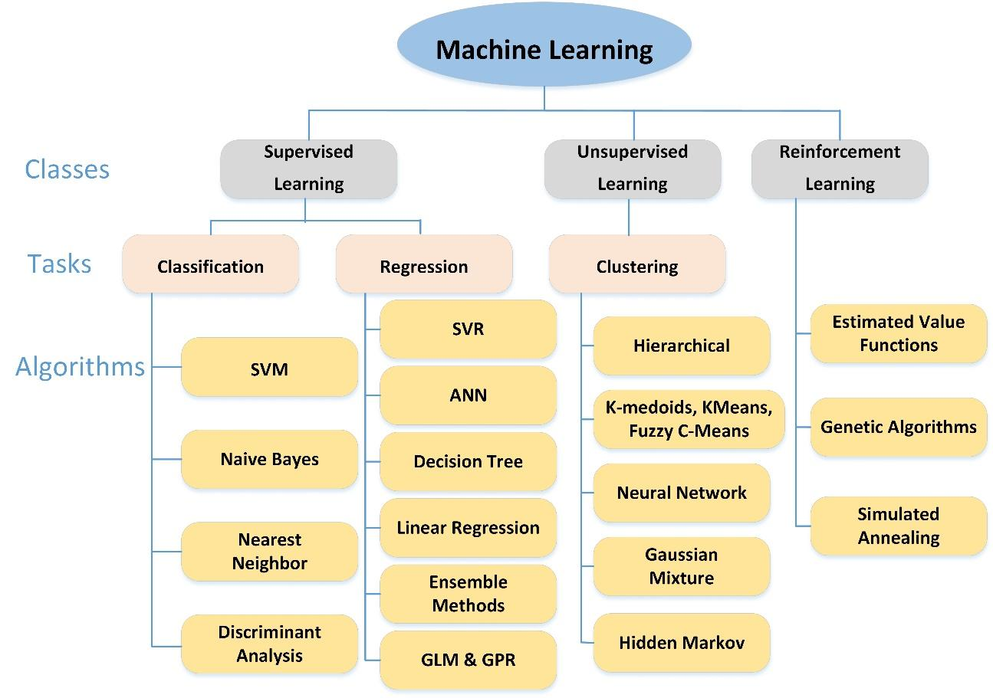
Fig 6. Machine Learning Techniques Classifications.
  - Supervised Learning
• Classification.

A “Support Vector Machine” (SVM) is one of the supervised machine learning technique that can be used when the original method of a real-world system is unidentified, or when obtaining a mathematical relationship is too costly due to the in-creased influence of a lot of interdependent elements. In a classification job, the samples are often considered to have two modules: negative & positive. An SVM training process creates a model that gives fresh patterns to one of the two groups, building a binary linear classifier that is non-probabilistic. The key distinction between different approaches when utilizing SVMs to classify bearings is the type and number of features employed. Table.1 clearly demonstrates this. (R. Medina et.al 2020) illustrates dual algorithms for feature extraction from the Poincaré plot that is constructed with the vibration signals for fault classification measured in gearboxes and bearings by using a multi-class Support Vector Machine. At the Salesian Polytechnic University in Cuenca, Ecuador, a rolling bearing test was constructed for vibration signal attainment, allowing for the conformation of various bearing health conditions as well as the measurement of vibration signals[31]. (Mehta et.al 2021) For fault categorization of different bearing states, an intelligent IRT-based system was presented. The obtained thermal pictures of various bearing situations were first preprocessed using 2D-DWT, followed by PCA selection of the most appropriate features, which then aids in classification and performance estimate using LDA, SVM, KNN, with SVM outper-forming both KNN and LDA [32]. (Glowacz et al 2021) The suggested work offers a fault diagnosis approach based on thermal image analysis. BCAoID (Binarized Common Areas of Image Differences) is a technique for extracting features from thermal images. Three electric impact drills (EIDs) were analyzed using thermal images: a healthy EID, an EID with a mal-functioning fan (10 cracked fan blades), and an EID with a damaged gear train. The BCAoID was used to calculate thermal image features[33]. (Tiwari et al.2017) proposed an examination of current and vibration monitoring for effective defect estimate in induction motors (IM) By multiclass support vector machine (MSVM) methods. Mechanical and electrical defects have been identified for maintenance purposes, both collectively and individually. Fault calculations have been made using only the vibration signal, only the current signal, and both the vibration and the current signal at the same time[34].
Table 1. Works related to bearing classification using Supervised Learning.
References | Dataset | Methods of diagnosis | Rate (%) | Faults type | Main points
R. Medina et al 2020 | Salesian Polytechnic University | SVM | 100 | Seven different types of roller bearing faults. | Developed a new feature extraction technique for vibration signals based on Poincaré plots, which allows for high classification accuracy using multi-class SVM.
Mehta et.al 2021 | 162 images | KNN, LDA ,SVM | 88,94,100 | 3 type of fault: healthy, inner race, and outer race | Identifies a variety of faults.  The IRT methodology performs well When compared to other methodologies for fault diagnosis
Glowacz et al 2021 | 90 thermal images | NN, BNN | 100, 97.91 | 10 Faulty fan, damaged gear-train | The study proposes employing BCAoID of three electric impact drills to analyse thermal pictures for fault identification (EID)
Tiwari et.al 2017 | Indian Institute of Technology Guwahati | SVM, MSVM | 93 | 4 faults of mechanical parts, 5 faults of electrical conditions parts and one Healthy | Diagnoses the electrical and mechanical faults.  SVM for electrical faults, MSVM better for mechanical faults.
Kang et al. 2017 | CWRU | SVM | 99 | Healthy, inner, rolling Element, outer | In this case, feature reduction using the LLE method yields the top results.
Toma et.al 2020 | University of Paderborn | KNN, DT, RF | 97 | Different load situations, three types of faults | ML 20 statistical characteristics were studied using a combination of genetic algorithms.  Computational complexity is reduced. A high level of precision was attained.
Ali et.al 2019 | Memorial University | KNN, Ensemble, SVM | 100 | 2 fault types (Motor1, Motor2) six loadings | Induction motor problems may be accurately detected using the suggested fault diagnosis approach, which can identify single or multiple electrical and mechanical flaws.
Moshrefzadeh 2021 | PoliTo, IMS, FEMTO data sets | S-KNN, SVM | 98 | bearing conditions | Compare the performance two classifiers S-KNN and SVM.  Under continual and changing operational conditions, online monitoring and intelligent diagnostics of rolling bearings is possible.
Kang et al. (2017) SVM classifications for bearing faults and fault sites were proposed. Using the relative recompense distance of multiple-domain characteristics and nearby linear embedding, a unique state assessment approach is developed in place of the traditional classification method for effectively assessing various fault locating and levels of performance degradation of a rolling bearing with a united estimate index [35]. In the context of PdM, k-NN has been frequently employed as one of the simplest ways for classification. For example, Toma et al. (2020) provides a hybrid motor-current data-driven technique for bearing defect diagnosis that incorporates genetic algorithms (GA), statistical features, and machine learning models. To evaluate the bearing flaws, researchers employed three classification algorithms: random forest, decision tree, and KNN. More than 97 percent accuracy was attained[36]. (Ali et.al 2019) proposed three classification algorithms K-nearest neighbors (KNN), support vector machine (SVM), and Ensemble based fault diagnosis method for two identical induction motors using trial data. There are two signal processing techniques Discrete Matching Pursuit (MP) and Wavelet Transform (DWT) is chosen for feature extraction. Induction motor problems may be accurately detected using the suggested fault diagnosis approach, which can identify single or multiple electrical and mechanical flaws[37]. A combination of SVM and KNN is also used in some solutions. (Moshrefzadeh 2021) proposed a newly approach for rolling element bearing failure detection and prognosis, as well as online condition monitoring, two approaches for data classification namely subspace k-nearest neighbors (S-KNN), support vector machine (SVM), are used that can distinguish amid different stag-es of machinery's health, regardless of weight or speed for data classification and diagnosis of the bearings[38]. Naive Bayes is a machine learning classifier that is basic, yet effective and widely used. It calculates the likelihood of each feature happening in each class and revenues the class with the maximum probability[39]. The Bayes rule is as follows:
P_{A/B} $=\frac{P\left(\frac{B}{A}\right)P(A)}{P(B)}$) (6)
Class and characteristics are represented by $A$ and $B$, respectively.
$P(A/B)$ is the possibility of belonging to class $A$ with all of the characteristics of class $B$. $P(B)$ is the probability of all characteristics, and it is used to normalize the data.

- Regression
ANN’s are a type of machine learning algorithm that has been proposed in a variety of industrial applications, including the soft sensing[40], predictive control[41]. (Bangalore et al.2018) the paper showed and suggested an artificial neural network (ANN)-based condition monitoring by a new solution employing data from supervisory control and data collecting systems of failures in the gearbox originating from the gearbox bearings to reduce the overall cost of wind turbine maintenance management[42]. (Kolokas et al.2018) Using the large-scale data processing engine Spark, propose LSTM networks are a form of recurrent ANN to predict the current engine state. Three operational settings and 21 sensors for measurements of the temperature, engine pressure, and fuel, and coolant bleed are included in this case[43]. Among the non-parametric supervised machine learning procedures that may be used for both regression and classification, the Decision tree technique is one of the most straightforward for optimal maintenance decision-making[44]. (Liu et al 2020) they offered a rolling bearing fault detection technique based on the numerous properties of local mean decomposition (LMD) and random forest. An accurate kind of rolling bearing failure is dune when the random forest technique is used. The overall percentage of recognition was 94.4 percent [45]. In the paper of (Abbasi et al.2018), it was the goal of the project is to create a user-friendly Graphical User Interface (GUI) program that uses the Various Linear Regression predictive maintenance method to create a user-friendly predictive maintenance data analytic interface. Using the proposed GUI and the Multiple Linear Regression approach, multiple data sets of Booster Compressor (BC) parameters are used to determine the accuracy of future prediction[46].

  - Unsupervised Learning
Unsupervised learning (UL) also famous as information detection makes use of training data that is unlabeled, unclassified, and uncategorized. Unsupervised learning's the main purpose is to find hidden and interesting patterns in unlabeled data[47]. Unsupervised learning methods, unlike supervised learning, can’t be immediately applied to a regression or classification problem because the output values are unknown. (Kramti et.al 2021) used a novel approach of vibration analysis in an innovative data driven strategy to immediate prognosis of HSSB . The suggested method is based on using Spectral Kurtosis to compute classical statistical measures obtained from the frequency-domain (SK) and time-domain . The most appropriate features were then chosen based on metrics (prognosablity, trendability, monotonicity ) to ensure a greater popularization of the prepared Elman Neural Network. The introduced approach was validated using the center for Intelligent Maintenance Systems' benchmark for training and real-world data from the Green Power Monitoring Systems (GPMS) for testing[48]. (Yang S et.al 2020) propose a new rolling bearing defect diagnostics approach depending on the Attention mechanism and a two-dimensional convolutional neural network. The results reveal that the upgraded Att-CNN2D network with the attention mechanism has a greater model generalization ability and accuracy than the classic CNN network[49]. (Jiang et.al 2018) suggested a new smart fault diagnosis strategy for automatically identifying different health problems of wind turbine (WT) gearboxes and detecting efficient failures immediately from vibration signals while classifying the type of faults in a single framework, then providing a learning-based fault diagnosis system for WT gearboxes without diagnostic expertise and extra signal processing [50].
Table 2. Works related to bearing classification using unsupervised Learning.
References | Dataset | Methods of diagnosis | Rate (%) | Faults type | - Main points
Francesca et.al 2019 | Motor data(1400 samples) | DNN | N/A | 4 faults, 4 loads | Detect faults in the motor bearings.
Kramti et.al 2021 | 3 bearings of the IMS offline and GPMS for online | ENN, RUL |  | 3 fault types,  Roller, inner, outer | This study tests their method on two separate bearing datasets using two different models.
Jiang et.al 2018 | wind turbine (20800 samples) | MSCNN | 97 | eight health conditions | Presents a novel MSCNN architecture for intelligent WT fault diagnostics under various operating situations.
Yang et.al 2020 | CWRU (7000 samples of 1HP, 2HP, and 3HP loads). | CNN, Att-CNN2D |  | 3 fault types,  Roller, inner, outer under three loads of 1, 2, and 3HP | Offer a novel approach for detecting rolling bearing faults using two-dimensional convolution in real working conditions
Pandarakone et.al 2019 | Motor data(3phase one load) | RF, CNN, DT, k-NN, SVM, DL | 81-89 | 3 fault types,  Healthy, failure with hole, failure with scratch | Detection of bearing faults and continuous monitoring using machine learning algorithms
Shao et.al 2021 | Thermal images (150 points, 104 target) | CNN | 81-95 | eight health states for bearing | Under various operating circumstances, a modified CNN was employed to diagnose thermal images of bearing faults
Liang et.al 2020 | CWRU 10,000 data points | WT-GAN-CNN | 98.38 | 4 load | The findings demonstrate that the suggested approach works in rotating equipment for single, simultaneous, and early weak failure modes.
Sobie et.al 2018 | CWRU, MFPT and SQ datasets | CNN, NNDTW | 99 | healthy and outer race fault | proposed Machine learning algorithms are being used in two new ways to identify faults., CNN and NNDTW applied to ASAs.
Zhiyi et al.2020 | Hunan University | CNN | 98 | 8 health states of rotor-bearing system(25 samples | On datasets of various bearings, several activation functions were compared between source and target was minimised.

(Shao et.al 2021) suggested a convolutional neural network (CNN) for rotor-bearing system fault diagnosis under varying working conditions by collecting and characterizing the health condition of the rotor-bearing system using infrared thermal images, then applied a modified CNN to overcome the training problems in classical CNN to analyse thermal images of the rotor-bearing system collected under varying working conditions[51]. (Liang et.al 2020) were proposed (WT-GAN-CNN) is a new intelligent failure detection solution for rotating equipment includes three parts. Wavelet Transform (WT) that converts 1-D Vibration data into 2-D (TF) time-frequency pictures. Generative Adversarial Nets (GANs) were employed to generate additional picture examples for training. convolutional neural network (CNN) utilized the real training time-frequency pictures and created false training time-frequency images to detect faults in rotating machinery[52]. (Korba et.al 2018) apply a novel an automated diagnosis of healthy and faulty bearing defects based on vibratory analysis using SVM, ANN, Neuro-Fuzzy Network (NFN) classifiers[53]. (Pandarakone et.al 2019) used machine learning (ML) algorithms and artificial intelligence (AI) for bearing faults diagnosis of induction motors (IM) For identifying a small bearing defect, multiple diagnosis algorithms from ML and AI are being considered (scratch, hole )[54]. (Alberto et. al 2018) provides an in-depth examination of artificial neural networks in wind energy systems, identifying the most commonly used methods for various applications and proving that in many circumstances, artificial neural networks can be a viable alternative to traditional approaches[55]. (Guo et al 2017) based on the performance of bearing health indicators, developed a recurrent neural network-based health indicator (RNN-HI) for forecasting bearing remaining useful life (RUL), as proven by two bearing data sets collected from tests and an industrial field[56]. (Francesca et.al. 2019) They employed the stator current from an inductor motor as input for their proposed bearing problem detection and monitoring system. They extracted numerous frequency and time features from the raw current measurements. A DNN was trained using the extracted features. Their proposed approach appears to provide a promising and effective classification, based on the presented data[57]. (Sobie et.al 2018) In his paper, he discuss-es how to train algorithms using simulation data, as well as how to use CNN and NNDTW to detect the presence of a bearing race defect using bearing acceleration signals[58]. (Gao et.al. 2018) suggested a novel fault type intelligent identification approach depended on a time frequency diagram and Convolution Neural Networks that transforms signal recognition into picture recognition (CNN) for rolling bearing fault diagnosis[59]. (Zhiyi et.al.2020) planned an enhanced convolutional neural net-work (ECNN) constructed since a convolutional auto encoder for smart rotor bearing system failure diagnostics utilizing tiny tagged infrared thermal photos (CAE). The benefits of the suggested method over current mainstream methodologies are demonstrated by the analysis and comparison results[60]. (Dhalmahapatra et.al 2019) The k-means pattern is a common clustering technique that determines a collection of clusters using an unsupervised strategy[61]. The Euclidean distance was used as a similarity criterion in the development of the k-means clustering algorithm. K-means is used in (Eke et al., 2017) to automatically extract groups (clusters) in liquified gases data in a converter's insulating oil. It was The goal to figure out what characteristics of each cluster cause a defect or an alert, so that maintenance actions could be taken[62]. The following are some examples of studies that employ k-means for PdM([63][64][62]). (Rustam et al.2017) present the Fuzzy Kernel k-Medoids (FKkMd) algorithm as a strong technique to tackle the anomaly detection-intrusion detection problem by combining fuzzy clustering, medoids, and kernel ideas[65]. The objective function value for the storage optimization problem is overestimated by K-shape, which changes as the number of clusters grows[66].
  - Reinforcement learning

Reinforcement learning, as one of the disciplines of machine learning, has several applications in many different of domains, including intelligent analysis and control, prediction[67]. Goal-directed learning and decision-making are the focus of (RL). Reinforcement learning differs from unsupervised learning in terms of goals; in unsupervised learning, the goal is to identify an appropriate action model that maximizes the agent's total cumulative reward.
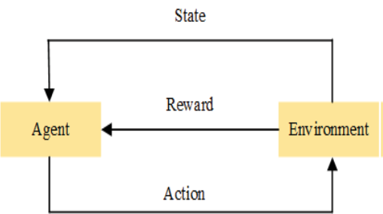
Design artificial intelligence for robotics and computer games, text summarizing engines, industrial automation, dialogue agents (speech, text), and other practical applications of reinforcement learning are only a few examples[47]. The main idea and components of the reinforcement learning model are depicted in Figure 7
In addition, (Han et al.2021) a new method for building a reinforcement learning Environment module based on a deep artificial neural network(DANN) It has been proposed, and an effective maintenance decision function has been created [68]. proposed RL for fault detection and diagnosis motor[69]. In fault classification, Reinforcement Learning for Convolutional Neural Network (RL-CNN) may automatically modify the learning rate and identify the optimum learning rate values based on its training history. [70].
Fig.7. reinforcement learning
- Challenges
Build accurate algorithms in order to properly and reliably process and prepare data for use as input into models that spend a long time. Inadequate access to adequate data leads to inaccurate predictions that may tolerate errors and excessive expectations and fixtures. Difficulty to build machine learning algorithms and data acquisition to apply predictive analytics without signal processing.
- Applications of ML algorithms in PdM
Machine learning is paving the way for smarter and faster data-driven decisions in predictive maintenance (PdM), and its use in industrial plants and infrastructure asset operations is already advancing at a rapid rate. Machine learning is becoming more popular due to the rise of big data and the expansion of the Industrial Internet of Things (IIoT). There are numerous applications for machine learning and PdM in the industrial sector.

Table 3. Works related to Applications of ML algorithms in PdM.
References | Dataset | Methods of diagnosis | Faults type | Main points
Du et al. 2018 [71] | SVM | Rolling bearing | Vibration  signals | Based on the TFIs, a method for fault monitoring in bearings was developed and to analyze non-stationary signals.
Ahmad et al.2019 [72] | Dynamic  regression | bearing | Vibration  measurements  data | Using regression model, predicts the state of bearing.  As a bearing state indicator, a dimensionless quantity was used.  TSP was calculated using ABT.  The PRONOSTIA dataset was used to validate and test the model to achieve a fair result In comparison to previous procedures
Jeong et al. 2018 [73] | GA-ANN, SVM | Gear  box -Rotating  machine | vibration signals and Acoustic  emission | Investigated a method for detecting prospective rotating machine faults early.  A increase in fault can be detected using the feature analysis method.
Kolokas et al. 2018[43] | ANN, RF, GNB DT | Anode  production | Sensor data. | PdM method for defect prediction in live time before the equipment failure.  5–10 minutes ahead of time, predicts failures in industrial equipment.
Manfre et al. 2020 [74] | DT ,K-nearest. NN,  Neighbors,  BNB, | rotating shaft | Vibration, temperature,  humidity , noise,  pressure, | With a precision loss of 5%, the Nave Bayes algorithm reaches its maximum peak.  Only the NN algorithm operates differently from the others.  The best results were obtained by increasing the training time by 20% with the isolation forest algorithm.
Cheng et al.2020 [75] | ANN, SVM | Building  facilities | Temperature,  Pressure sensor | The introduction of PdM to increase the feasibility of the FMM process was made easier thanks to BIM and IoT.  For maintenance, four modules are used: 1- prediction of condition , 2- planning of maintenance , 3- monitoring, and 4- evaluation of condition .
Koca et al.2020 [76] | ANN | Packaging robots | Vibration,  temperature,  humidity | The MLP framework can withstand unanticipated outages.  Can significantly reduce the expenses of unplanned production downtime.  Failures are compared both theoretically and practically.
Gohel et al.2020 [77] | SVM,LR | Nuclear infrastructure | Temperature,  power, current,  speed | Maintenance of nuclear infrastructure can be predicted using a machine learning system.  The consumption of electricity is kept track of and record The temperature of electrical panels
Janssens et al. 2018 [78] | DNN-CNN,  DL | Rotating  machinery | Accelerometer,  thermocouple, camera  measurements | The CNN algorithm was used to detect a variety of rotating equipment situations.  Online condition monitoring in wind turbines can be improved with this technology.  It can be used to monitor bearings in manufacturing lines.  CNN outperforms in machine fault detection and oil level prediction.  When compared to the FE technique, the FL technique performs 6.7 % better.
Zhang et al.2018 [79] | NN | Gas turbine | Gas  measurements | For starting deterioration monitoring, a NN and physics-based model was developed.  Both models are capable of monitoring the starter's health and displaying indicators of degeneration.  When the starters are in good shape, NN offers more accurate outcomes.  On starters with increasing degradations, physics-based delivers superior results.
Janssens et al. 2018 [80] | RF | Rotating machine | vibration | Heat or vibration deficiencies can be corrected with a multi-sensor system for rotary machines.  Increases the accuracy of fault detection by a significant amount.
Hoffmann et al. 2020 [81] | SVM, RNN,  k-nearest  neighbor | Switchgear | Voltage, Temperature,  Current | The use of cutting-edge sensor technologies in conjunction with machine learning techniques.  Predictive maintenance solutions for medium voltage switchgear are provided..
Cheng et al. 2020 [82] | WD-DTL, CNN, DAN | bearing | US-Speed  , US-Location | Addressing industrial domain shift problems by intelligent fault diagnosis based (WD-DTL).  WD-DTL helps solve difficulties with unlabeled and inadequately labelled data.
- Discussion and Conclusions
Based on the literature study in last five years through this review in many cases for ML techniques are increasingly being utilized to draw the visualizations of PdM, combining PdM and ML yields positive results as well as cost maintenance savings in bearing and generally all rotary machines. However, it is clear that combining PdM methodologies with cutting-edge sensor technology reduces the need for wasteful equipment replacement, saves money, and enhances the safety, availability, and efficiency of the process. The study provides a complete overview of machine learning techniques used in PdM of bearing Failures in rotary machines in industrial components that relies on numerous scenarios and forecast what will go wrong and when - and then create alerts based on vast volumes of historical or test data mixed with specific machine-learning algorithms. Several machine learning methods have been studied and presented in recent applications on Predictive maintenance throughout the last five years (from 2017–2021). Predictive maintenance has been proven to give significant commercial benefits, and Machine learning is a cutting-edge method for doing predictive maintenance. Only 11% of studied organizations have 'realized' machine learning based “predictive maintenance”, according to a PWC report[83]. According to the literature study, the most common information type employed is real, Only a little research have used simulated data to build machine learning algorithms.. example Bosch, SECOM, CMAPSS, Case Western Reserve University and NASA datasets on engine degradation were used in the development of ML algorithm PdM models. Furthermore, some of the research's findings use standard machine learning algorithms with no parameter adjustment. Perhaps this is because PdM is a novel issue for manufacturing specialists, and it is only now being investigated. It's also worth noting that, in order to achieve positive outcomes from a PdM strategy in a plant, the PvM and R2F strategies should already be in place in the process of collecting data for PdM modeling.
Finally, The ultimate objective of this research, in a broader perspective, is to undertake effective predictive maintenance before faults damage the system as a whole. The assessed use cases described in this paper demonstrate that machine learning can successfully forecast failures or irregularities in a variety of applications. We've given several ideas for additional study in this paper:
• Predictive maintenance may be automated with the aid of an intelligent real-time data collecting system.
• When compared to a single ML model, employing several ML models can result in better predictions.
• By combining classification and defect detection methods, PdM may be utilized on equipment or systems that do not have a large data collection.
• All system failures can't be predicted through one model, and not all machine learning models can be developed using the same technique.

Table 4 lists the key terminologies used in this paper.
Table-4. Nomenclature.
References | Main points
PdM | Predictive Maintenance
PvM | Preventive Maintenance
R2F | Run-to-Failure
SVM | Support Vector Machine
WT | Wind Turbine
k-NN | k-Nearest Neighbors
IEEE | Institute of Electronics and Electrical Engineers
ANN | Artificial Neural Network
CMS | Condition Monitoring System
PAT | Predictive Analytics Toolkit
AI | Artificial Intelligence
ML | Machine Learning
CBM | Condition-based maintenance
IMS | Intelligent Maintenance Systems
GPMS | Green Power Monitoring Systems
ENN | Elman Neural Network
RUL | Remaining Useful Life
DNN | Deep Neural Network
CWRU | Case Western Reserve University
MFPT | Machine failure prevention technology
IRT | Infrared thermal images
DT | Decision Tree
LR | Linear Regression
TFI | Time–frequency image
RL | Reinforcement learning
WD-DTL | Wasserstein distance based deep transfer learning
DAN | Deep Adaptation Network
NNDTW | Nearest-neighbor dynamic time warping
IMS | Intelligent Maintenance Systems
- References
[1] J. Para, J. Del Ser, A. J. Nebro, U. Zurutuza, and F. Herrera, “Analyze, Sense, Preprocess, Predict, Implement, and Deploy (ASPPID): An incremental methodology based on data analytics for cost-efficiently monitoring the industry 4.0” Eng. Appl. Artif. Intell., vol. 82, no. September 2018, pp. 30–43, 2019.
[2] R. S. Peres, A. Dionisio Rocha, P. Leitao, and J. Barata, “IDARTS – Towards intelligent data analysis and real-time supervision for industry 4.0,” Comput. Ind., vol. 101, no. July, pp. 138–146, 2018.
[3] T. P. Carvalho, F. A. A. M. N. Soares, R. Vita, R. da P. Francisco, J. P. Basto, and S. G. S. Alcalá, “A systematic literature review of machine learning methods applied to predictive maintenance,” Comput. Ind. Eng., vol. 137, no. September, p. 106024, 2019.
[4] R. C. Parpala and R. Iacob, “Application of IoT concept on predictive maintenance of industrial equipment,” vol. 02008, pp. 1–8, 2017.
[5] P. Ongsulee, V. Chotchaung, E. Bamrungsi, and T. Rodcheewit, “Big Data, Predictive Analytics and Machine Learning,” Int. Conf. ICT Knowl. Eng., vol. 2018-Novem, pp. 37–42, 2019.
[6] J. Dalzochio et al., “Machine learning and reasoning for predictive maintenance in Industry 4.0: Current status and challenges,” Comput. Ind., vol. 123, p. 103298, 2020.
[7] J. Sri, L. Senanayaka, H. Van Khang, K. G. Robbersmyr, and S. M. Ieee, “Online Fault Diagnosis System for Electric Powertrains using Advanced Signal Processing and Machine Learning,” 2018 XIII Int. Conf. Electr. Mach., pp. 1932–1938, 2018.
[8] A. I. Vlasov, V. V. Echeistov, A. I. Krivoshein, V. A. Shakhnov, S. S. Filin, and V. S. Migalin, “An information system of predictive maintenance analytical support of industrial equipment,” J. Appl. Eng. Sci., vol. 16, no. 4, pp. 515–522, 2018.
[9] M. Calabrese et al., “SOPHIA: An event-based IoT and machine learning architecture for predictive maintenance in industry 4.0,” Inf., vol. 11, no. 4, pp. 1–17, 2020.
[10] O. Alshorman et al., “A Review of Artificial Intelligence Methods for Condition Monitoring and Fault Diagnosis of Rolling Element Bearings for Induction Motor,” Shock Vib., vol. 2020, no. Cm, 2020.
[11] S. B. Jiang, P. K. Wong, R. Guan, Y. Liang, and J. Li, “An Efficient Fault Diagnostic Method for Three-Phase Induction Motors Based on Incremental Broad Learning and Non-Negative Matrix Factorization,” IEEE Access, vol. 7, pp. 17780–17790, 2019.
[12] Nacchia, Fruggiero, Lambiase, and Bruton, “A systematic mapping of the advancing use of machine learning techniques for predictive maintenance in the manufacturing sector,” Appl. Sci., vol. 11, no. 6, pp. 1–34, 2021.
[13] Y. Chen, G. Peng, C. Xie, W. Zhang, C. Li, and S. Liu, “ACDIN: Bridging the gap between artificial and real bearing damages for bearing fault diagnosis,” Neurocomputing, vol. 294, pp. 61–71, 2018.
[14] P. Štastniak, R. Kohár, and L. Smetanka, “Dynamic analysis of force interactions in rolling bearings components,” AIP Conf. Proc., vol. 2198, no. December, pp. 1–7, 2019.
[15] D. Wu et al., “An automatic bearing fault diagnosis method based on characteristics frequency ratio,” Sensors (Switzerland), vol. 20, no. 5, pp. 1–12, 2020.
[16] I. Attoui, N. Fergani, N. Boutasseta, B. Oudjani, and A. Deliou, “A new time–frequency method for identification and classification of ball bearing faults,” J. Sound Vib., vol. 397, pp. 241–265, 2017.
[17] T. Haj Mohamad and C. Nataraj, “Fault identification and severity analysis of rolling element bearings using phase space topology,” JVC/Journal Vib. Control, vol. 27, no. 3–4, pp. 295–310, 2021.
[18] J. J. Saucedo-Dorantes, M. Delgado-Prieto, J. A. Ortega-Redondo, R. A. Osornio-Rios, and R. D. J. Romero-Troncoso, “Multiple-Fault Detection Methodology Based on Vibration and Current Analysis Applied to Bearings in Induction Motors and Gearboxes on the Kinematic Chain,” Shock Vib., vol. 2016, 2016.
[19] M. Kuncan, “An Intelligent Approach for Bearing Fault Diagnosis: Combination of 1D-LBP and GRA,” IEEE Access, vol. 8, pp. 137517–137529, 2020.
[20] S. Zhang et al., “Model-Based Analysis and Quantification of Bearing Faults in Induction Machines,” IEEE Trans. Ind. Appl., vol. 56, no. 3, pp. 2158–2170, 2020.
[21] D. Yang, J. Miao, F. Zhang, J. Tao, G. Wang, and Y. Shen, “Bearing Fault Diagnosis Using a Support Vector Machine Optimized by an Improved Ant Lion Optimizer,” Shock Vib., vol. 2019, 2019.
[22] X. Qin, D. Xu, X. Dong, X. Cui, and S. Zhang, “The Fault Diagnosis of Rolling Bearing Based on Improved Deep Forest,” Shock Vib., vol. 2021, 2021.
[23] B. Zheng, H. Gao, X. Ma, and X. Zhang, “Multiteam Competitive Optimization Algorithm and Its Application in Bearing Fault Diagnosis,” Math. Probl. Eng., vol. 2021, 2021.
[24] J. A. Brumbach, M.E. and Clade, “Industrial Maintenance - Michael E. Brumbach, Jeffrey A. Clade - Google Books,” Cengage Learning, 2013.[Online].Availble:https://books.google.co.in/books?id=fTc9AAAAQBAJ&pg=PA166&lpg=PA166&dq=The+excessive+load+usually+causes+premture+spalled+area+in+the+ball+path&source=bl&ots=BpgZpa379N&sig=ACfU3U3FHzngdGDq_isw8GScvSpjMB3LA&hl=en&sa=X&ved=2ahUKEwjOyabbneXyAhXiwzgGHdJEAk. [Accessed: 04-Sep-2021].
[25] X. Shi et al., “An Improved Bearing Fault Diagnosis Scheme Based on Hierarchical Fuzzy Entropy and Alexnet Network,” IEEE Access, vol. 9, pp. 61710–61720, 2021.
[26] A. P. Ompusunggu, T. Ooijevaar, B. Kilundu Y‘Ebondo, and S. Devos, “Automated bearing fault diagnostics with cost-effective vibration sensor,” Lect. Notes Mech. Eng., no. August, pp. 463–472, 2019.
[27] S. X. and J. L. Aijun Hu*, Ling Xiang, “Frequency Loss and Recovery in Rolling Bearing Fault Detection.pdf.” 2019.
[28] A. I. Kadhim, “Survey on supervised machine learning techniques for automatic text classification,” Artif. Intell. Rev., vol. 52, no. 1, pp. 273–292, 2019.
[29] M. Usama et al., “Unsupervised Machine Learning for Networking: Techniques, Applications and Research Challenges,” IEEE Access, vol. 7, pp. 65579–65615, 2019.
[30] A. K. Mondal, “A Survey of Reinforcement Learning Techniques: Strategies, Recent Development, and Future Directions,” no. September, 2020.
[31] R. Medina et al., “Gear and bearing fault classification under different load and speed by using Poincaré plot features and SVM,” J. Intell. Manuf.
[32] A. Mehta, D. Goyal, A. Choudhary, B. S. Pabla, and S. Belghith, “Machine Learning-Based Fault Diagnosis of Self-Aligning Bearings for Rotating Machinery Using Infrared Thermography,” Math. Probl. Eng., vol. 2021, 2021.
[33] A. Glowacz, “Fault diagnosis of electric impact drills using thermal imaging,” Meas. J. Int. Meas. Confed., vol. 171, no. November 2020, p. 108815, 2021.
[34] P. Gangsar and R. Tiwari, “Comparative investigation of vibration and current monitoring for prediction of mechanical and electrical faults in induction motor based on multiclass-support vector machine algorithms,” Mech. Syst. Signal Process., vol. 94, pp. 464–481, 2017.
[35] S. Kang, D. Ma, Y. Wang, C. Lan, Q. Chen, and V. I. Mikulovich, “Method of assessing the state of a rolling bearing based on the relative compensation distance of multiple-domain features and locally linear embedding,” Mech. Syst. Signal Process., vol. 86, no. 52, pp. 40–57, 2017.
[36] R. N. Toma, A. E. Prosvirin, and J. M. Kim, “Bearing fault diagnosis of induction motors using a genetic algorithm and machine learning classifiers,” Sensors (Switzerland), vol. 20, no. 7, 2020.
[37] M. Z. Ali, M. N. S. K. Shabbir, X. Liang, Y. Zhang, and T. Hu, “Machine learning-based fault diagnosis for single- and multi-faults in induction motors using measured stator currents and vibration signals,” IEEE Trans. Ind. Appl., vol. 55, no. 3, pp. 2378–2391, 2019.
[38] A. Moshrefzadeh, “Condition monitoring and intelligent diagnosis of rolling element bearings under constant/variable load and speed conditions,” Mech. Syst. Signal Process., vol. 149, p. 107153, 2021.
[39] S. Chowdhury and M. P. Schoen, “Research Paper Classification using Supervised Machine Learning Techniques,” 2020 Intermt. Eng. Technol. Comput. IETC 2020, 2020.
[40] V. Brunner, M. Siegl, D. Geier, and T. Becker, “Challenges in the Development of Soft Sensors for Bioprocesses: A Critical Review,” Front. Bioeng. Biotechnol., vol. 9, no. August, pp. 1–21, 2021.
[41] S. Bayhan and H. Abu-Rub, Predictive Control of Power Electronic Converters, 4th ed. Elsevier Inc., 2018.
[42] P. Bangalore and L. B. Tjernberg, “An artificial neural network approach for early fault detection of gearbox bearings,” IEEE Trans. Smart Grid, vol. 6, no. 2, pp. 980–987, 2015.
[43] N. Kolokas, T. Vafeiadis, D. Ioannidis, and D. Tzovaras, “Forecasting faults of industrial equipment using machine learning classifiers,” 2018 IEEE Int. Conf. Innov. Intell. Syst. Appl. INISTA 2018, pp. 1–6, 2018.
[44] S. Kaparthi and D. Bumblauskas, “Designing predictive maintenance systems using decision tree-based machine learning techniques,” Int. J. Qual. Reliab. Manag., vol. 37, no. 4, pp. 659–686, 2020.
[45] N. Liu, B. Liu, and C. Xi, “Fault diagnosis method of rolling bearing based on the multiple features of LMD and random forest,” IOP Conf. Ser. Mater. Sci. Eng., vol. 892, no. 1, 2020.
[46] T. Abbasi, K. H. Lim, N. S. Rosli, I. Ismail, and R. Ibrahim, “Development of Predictive Maintenance Interface Using Multiple Linear Regression,” Int. Conf. Intell. Adv. Syst. ICIAS 2018, pp. 1–5, 2018.
[47] K. El Bouchefry and R. S. de Souza, Learning in Big Data: Introduction to Machine Learning. Elsevier Inc., 2020.
[48] S. E. Kramti, J. Ben Ali, L. Saidi, M. Sayadi, M. Bouchouicha, and E. Bechhoefer, “A neural network approach for improved bearing prognostics of wind turbine generators,” EPJ Appl. Phys., vol. 93, no. 2, 2021.
[49] S. Yang, X. Sun, and D. Chen, “Bearing fault diagnosis of two-dimensional improved Att-CNN2D neural network based on Attention mechanism,” Proc. 2020 IEEE Int. Conf. Artif. Intell. Inf. Syst. ICAIIS 2020, pp. 81–85, 2020.
[50] G. Jiang, H. He, J. Yan, and P. Xie, “Multiscale Convolutional Neural Networks for Fault Diagnosis of Wind Turbine Gearbox,” IEEE Trans. Ind. Electron., vol. PP, no. c, p. 1, 2018.
[51] H. Shao, M. Xia, G. Han, Y. Zhang, and J. Wan, “Intelligent Fault Diagnosis of Rotor-Bearing System under Varying Working Conditions with Modified Transfer Convolutional Neural Network and Thermal Images,” IEEE Trans. Ind. Informatics, vol. 17, no. 5, pp. 3488–3496, 2021.
[52] P. Liang, C. Deng, J. Wu, and Z. Yang, “Intelligent fault diagnosis of rotating machinery via wavelet transform, generative adversarial nets and convolutional neural network,” Meas. J. Int. Meas. Confed., vol. 159, p. 107768, 2020.
[53] K. A. Korba and F. Arbaoui, “SVM Multi-Classification of Induction Machine ’ s bearings defects using Vibratory Analysis based on Empirical Mode Decomposition,” vol. 13, no. 9, pp. 6579–6586, 2018.
[54] S. E. Pandarakone, Y. Mizuno, and H. Nakamura, “Algorithm and Artificial Intelligence Neural Network,” Energies, vol. 12, p. 2105, 2019.
[55] A. P. Marugán, F. P. G. Márquez, J. M. P. Perez, and D. Ruiz-Hernández, “A survey of artificial neural network in wind energy systems,” Appl. Energy, vol. 228, no. April, pp. 1822–1836, 2018.
[56] L. Guo, N. Li, F. Jia, Y. Lei, and J. Lin, “A recurrent neural network based health indicator for remaining useful life prediction of bearings,” Neurocomputing, vol. 240, pp. 98–109, 2017.
[57] F. Cipollini, L. Oneto, A. Coraddu, and S. Savio, “Unsupervised Deep Learning for Induction Motor Bearings Monitoring,” Data-Enabled Discov. Appl., vol. 3, no. 1, 2019.
[58] C. Sobie, C. Freitas, and M. Nicolai, “Simulation-driven machine learning: Bearing fault classification,” Mech. Syst. Signal Process., vol. 99, pp. 403–419, 2018.
[59] D. Gao et al., “A Fault Diagnosis Method of Rolling Bearing Based on Complex Morlet CWT and CNN,” 2018 Progn. Syst. Heal. Manag. Conf., pp. 1101–1105, 2018.
[60] H. Zhiyi, S. Haidong, Z. Xiang, Y. Yu, and C. Junsheng, “An intelligent fault diagnosis method for rotor-bearing system using small labeled infrared thermal images and enhanced CNN transferred from CAE,” Adv. Eng. Informatics, vol. 46, no. April, p. 101150, 2020.
[61] K. Dhalmahapatra, R. Shingade, H. Mahajan, A. Verma, and J. Maiti, “Decision support system for safety improvement: An approach using multiple correspondence analysis, t-SNE algorithm and K-means clustering,” Comput. Ind. Eng., vol. 128, no. June 2018, pp. 277–289, 2019.
[62] Eke, S., Aka-Ngnui, T., Clerc, G., & Fofana, I. "Characterization of the operating periods of a power transformer by clustering the dissolved gas data." IEEE 11th International Symposium on Diagnostics for Electrical Machines, Power Electronics and Drives (SDEMPED) (2017).
[63] N. Amruthnath and T. Gupta, “A research study on unsupervised machine learning algorithms for early fault detection in predictive maintenance,” 2018 5th Int. Conf. Ind. Eng. Appl. ICIEA 2018, no. August 1993, pp. 355–361, 2018.
[64] V. Mathew, T. Toby, V. Singh, B. M. Rao, and M. G. Kumar, “Prediction of Remaining Useful Lifetime (RUL) of turbofan engine using machine learning,” IEEE Int. Conf. Circuits Syst. ICCS 2017, vol. 2018-Janua, no. Iccs, pp. 306–311, 2018.
[65] Z. Rustam and A. S. Talita, “Fuzzy Kernel k-Medoids algorithm for anomaly detection problems,” AIP Conf. Proc., vol. 1862, no. July 2017, 2017.
[66] H. Teichgraeber and A. R. Brandt, Systematic Comparison of Aggregation Methods for Input Data Time Series Aggregation of Energy Systems Optimization Problems, vol. 44. Elsevier Masson SAS, 2018.
[67] W. Dai, Z. Mo, C. Luo, J. Jiang, and Q. Miao, “Bearing Fault Diagnosis Based on Reinforcement Learning and Kurtosis,” 2019 Progn. Syst. Heal. Manag. Conf. PHM-Qingdao 2019, no. 1, pp. 1–5, 2019.
[68] C. Han, T. Ma, and S. Chen, “Asphalt pavement maintenance plans intelligent decision model based on reinforcement learning algorithm,” Constr. Build. Mater., vol. 299, no. February, p. 124278, 2021.
[69] W. Zhang and J. Zhu, “A reinforcement learning system for fault detection and diagnosis in mechatronic systems,” C. - Comput. Model. Eng. Sci., vol. 124, no. 3, pp. 1119–1130, 2020.
[70] L. Wen, X. Li, and L. Gao, “A New Reinforcement Learning Based Learning Rate Scheduler for Convolutional Neural Network in Fault Classification,” IEEE Trans. Ind. Electron., vol. 68, no. 12, pp. 12890–12900, 2021.
[71] Y. Du, Y. Chen, G. Meng, J. Ding, and Y. Xiao, “Fault severity monitoring of rolling bearings based on texture feature extraction of sparse time-frequency images,” Appl. Sci., vol. 8, no. 9, pp. 1–23, 2018.
[72] W. Ahmad, S. A. Khan, M. M. M. Islam, and J. M. Kim, “A reliable technique for remaining useful life estimation of rolling element bearings using dynamic regression models,” Reliab. Eng. Syst. Saf., vol. 184, pp. 67–76, 2019.
[73] and B.-K. C. Jeong-Min Ha1, Hyeon-Jung Kim1, Yoo-Soo Shin2, “Degradation Trend Estimation and Prognostics for LowSpeed Gear Lifetime.” .
[74] M. Manfre, “Creation of a Machine Learning model for the Predictive Maintenance of an engine equipped with a rotating shaft,” no. March, 2020.
[75] J. C. P. Cheng, W. Chen, K. Chen, and Q. Wang, “Data-driven predictive maintenance planning framework for MEP components based on BIM and IoT using machine learning algorithms,” Autom. Constr., vol. 112, no. August 2018, p. 103087, 2020.
[76] O. Koca, O. T. Kaymakci, and M. Mercimek, “Advanced Predictive Maintenance with Machine Learning Failure Estimation in Industrial Packaging Robots,” 2020 15th Int. Conf. Dev. Appl. Syst. DAS 2020 - Proc., pp. 1–6, 2020.
[77] H. A. Gohel, H. Upadhyay, L. Lagos, K. Cooper, and A. Sanzetenea, “Predictive maintenance architecture development for nuclear infrastructure using machine learning,” Nucl. Eng. Technol., vol. 52, no. 7, pp. 1436–1442, 2020.
[78] O. Janssens, R. Van De Walle, M. Loccufier, and S. Van Hoecke, “Deep Learning for Infrared Thermal Image Based Machine Health Monitoring,” IEEE/ASME Trans. Mechatronics, vol. 23, no. 1, pp. 151–159, 2018.
[79] Y. Zhang, J. Liu, H. Hanachi, X. Yu, and Y. Yang, “Physics-based Model and Neural Network Model for Monitoring Starter Degradation of APU,” 2018 IEEE Int. Conf. Progn. Heal. Manag. ICPHM 2018, pp. 1–7, 2018.
[80] O. Janssens, M. Loccufier, and S. Van Hoecke, “Thermal Imaging and Vibration-Based Multisensor Fault Detection for Rotating Machinery,” IEEE Trans. Ind. Informatics, vol. 15, no. 1, pp. 434–444, 2019.
[81] M. W. Hoffmann et al., “Integration of novel sensors and machine learning for predictive maintenance in medium voltage switchgear to enable the energy and mobility revolutions,” Sensors (Switzerland), vol. 20, no. 7, pp. 1–24, 2020.
[82] C. Cheng, B. Zhou, G. Ma, D. Wu, and Y. Yuan, “Wasserstein distance based deep adversarial transfer learning for intelligent fault diagnosis with unlabeled or insufficient labeled data,” Neurocomputing, vol. 409, pp. 35–45, 2020.
[83] Seebo, “Why Predictive Maintenance is Driving Industry 4.0,” i4.0 Initiat., pp. 1–13, 2019.

